|  |  |
| --- | --- |
|  | Signature  KHULNA UNIVERSITY OF ENGINEERING & TECHNOLOGY  KHULNA-9203 Project Name:CSE 3200: Software Development Project-II Butterfly: Fun, Share LearnSubmitted To: Mr. Jakaria Rabbi LecturerDepartment of Computer Science and EngineeringKhulna University of Engineering & Technology, khulna-9203Submitted by:Md. Sharif KhanRoll: 1307034&&Md. Jahirul IslamRoll: 1307035 |

###### Table of Contents

Serial No Name of Contents Page Number

1. Introduction 3
2. Objective 3
3. Project Structure 4
4. Control flow in the Project 5
5. Interface 7
6. Database Schema Design & Block Diagram 11
7. Features and usefulness 13
8. Limitations 14
9. Future Plan 14
10. Conclusion 15
11. Reference 15
12. Acknowledgment 16
13. Introduction

Now in the life of internet it is very common for everyone to share video with everyone and also learn from it sometimes. For that purpose we need a common platform for sharing purpose like a website which will have some features as upload, view, like, commend etc. under a user. So, here we come with a brand new website named “Butterfly: Share, Fun & Learn”. It is made with HTML5 embedded CSS && php. In backend we used SQL && ffmpeg for server and database purpose.

1. Objective
2. To connect people under a single platform
3. To keep user anonymous to ensure user confidentiality
4. To share knowledge with everyone
5. To make the world a better place
6. Project structure

On the journey to do the project at first we make a HTML skeleton page. Then we embedded CSS with it to make it more dynamic. Then taking that we give it PHP action with SQL database. That how it works. The website use normal HTML CSS structure to get a user upload a video without showing their profile.

**HTML**

**CSS**

**PHP**

**SQL**

1. Control flow in the project

This is video site on which user (only users) can upload videos. Others can view without being user. So, for uploading video you have to be user. The project section is very simple.

* Home
* User profile
* Upload page
* Login page
* Signup page
* Video page
* Search page

Let’s see the Control Flow of the project:

# Normal VieweR

Video Page

HOME Page

Login/Signup

# Signed user

Logout

Upload Video

Profile Page

Video Page

HOME Page

Signup

Login

1. interface

Below this is the homepage of the website

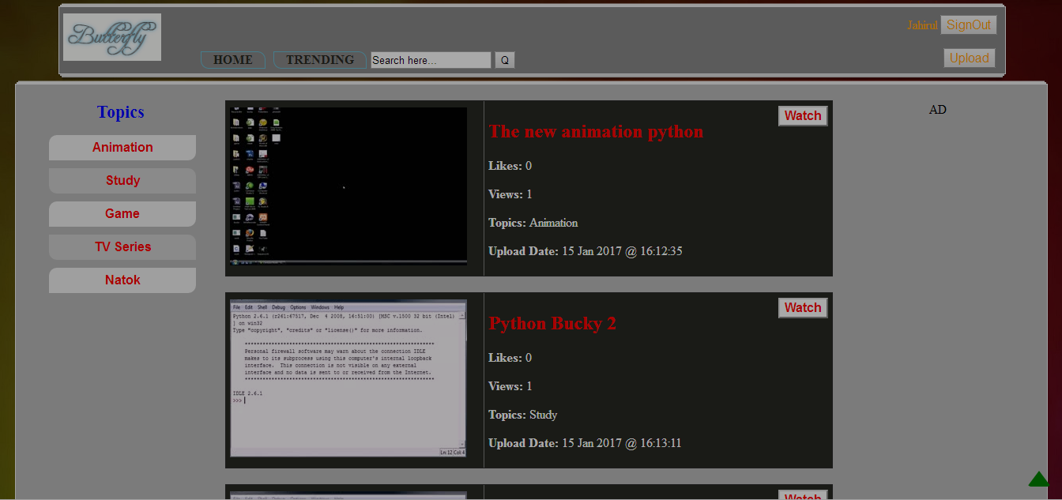

Now let’s see the video player page

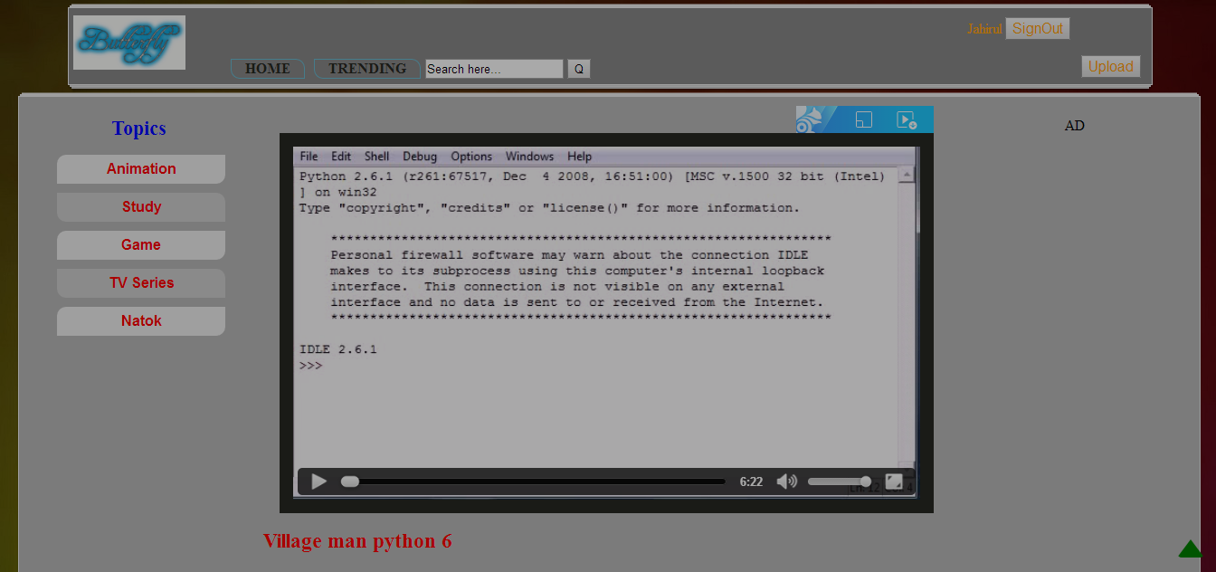

Login page will be like this

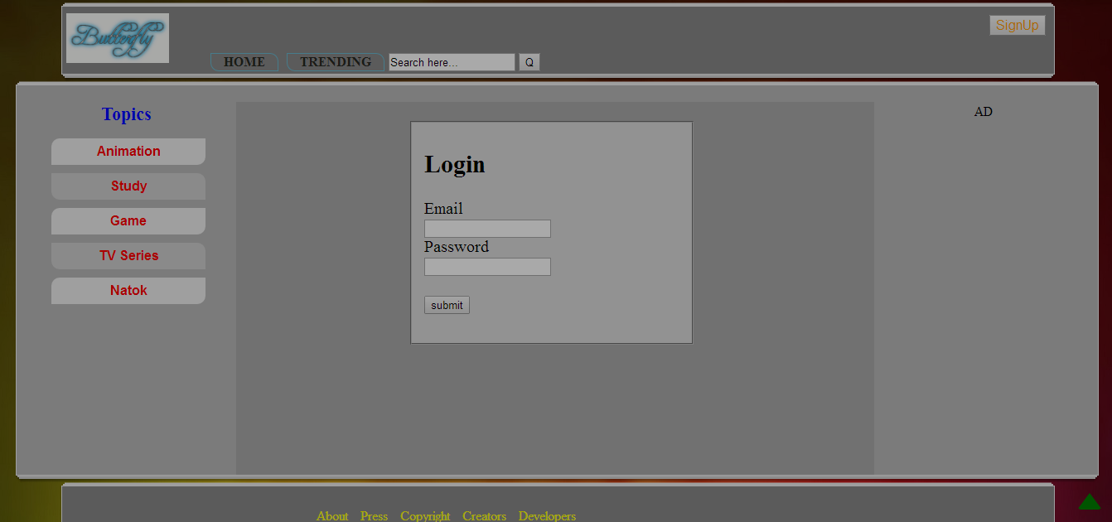

And signup page will be like this

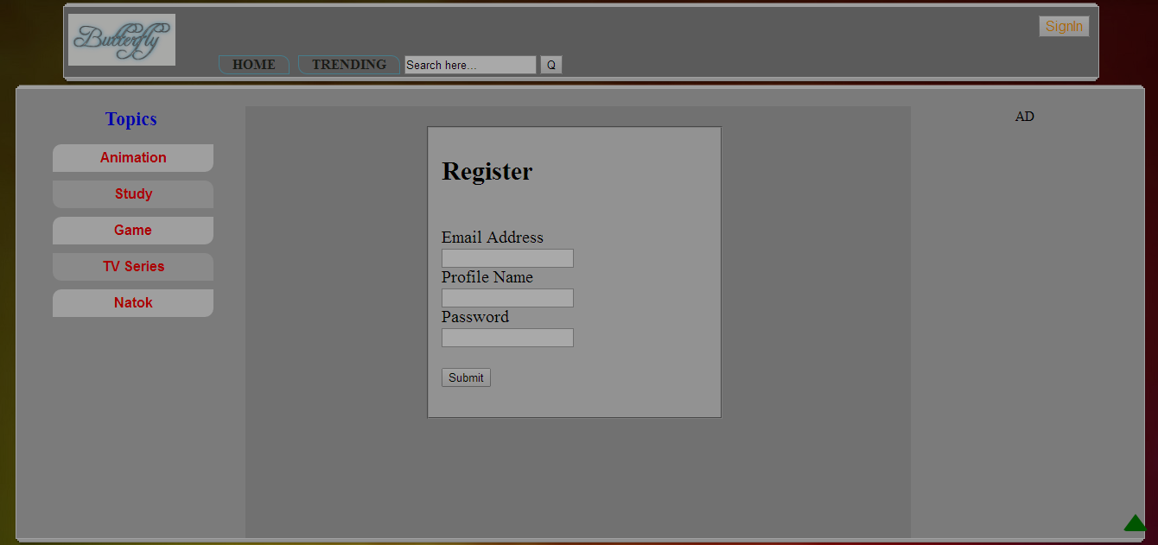

Search page going to be like this

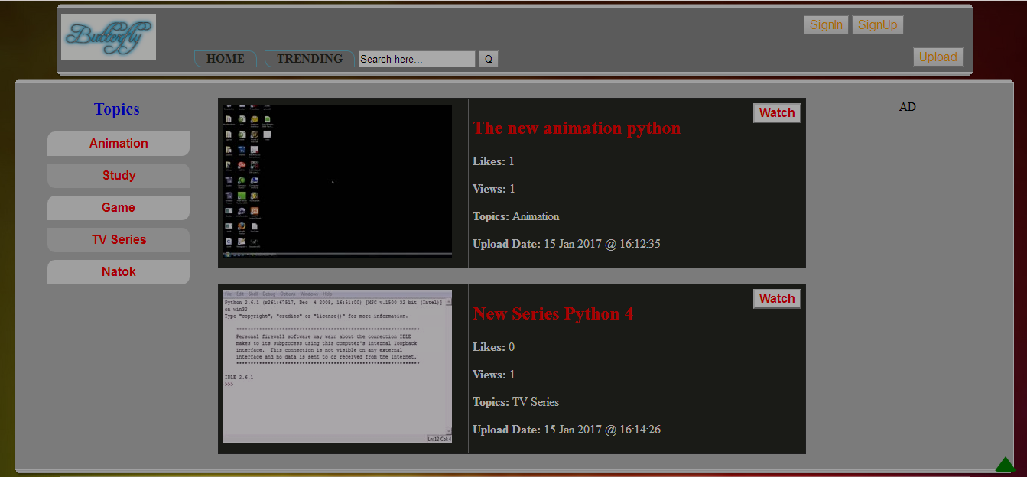

Uploading a video page like this

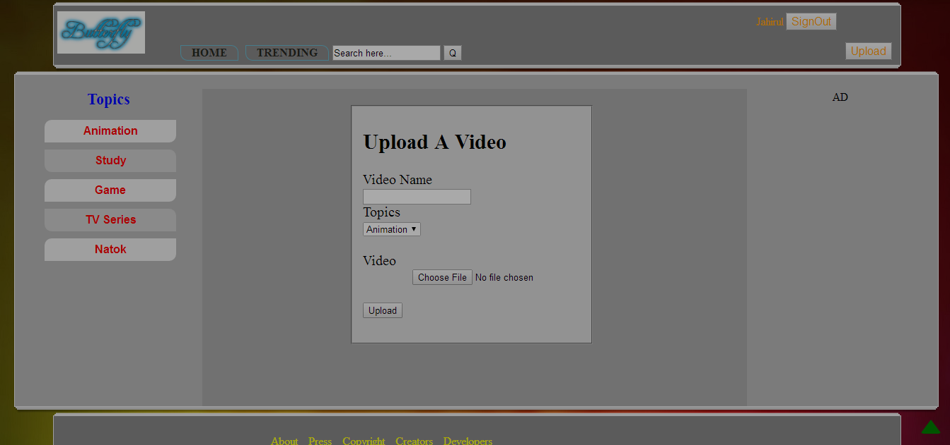

And lastly commenting box with option

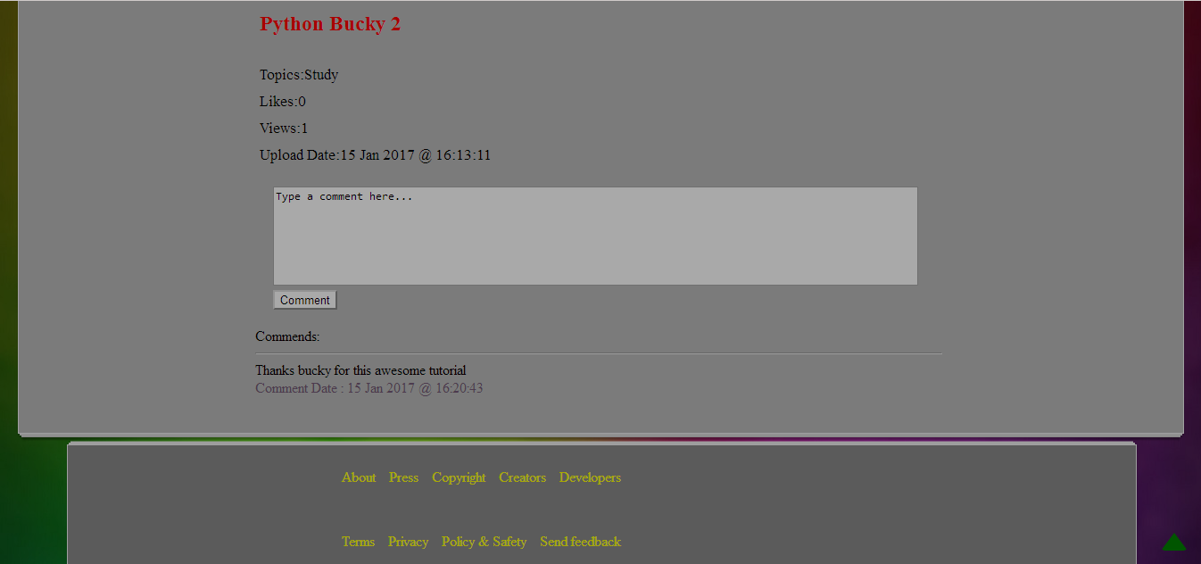

1. Database schema design & block diagram

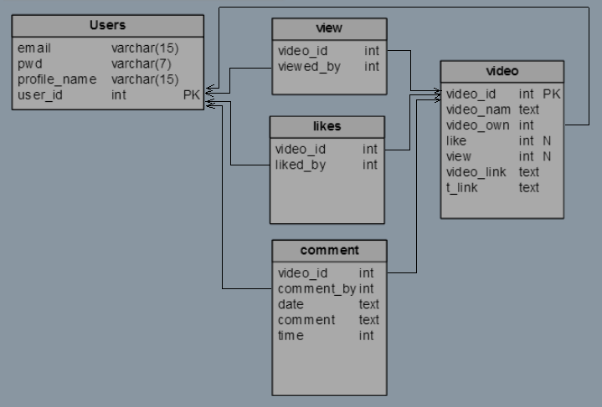

Fig: Schema Diagram

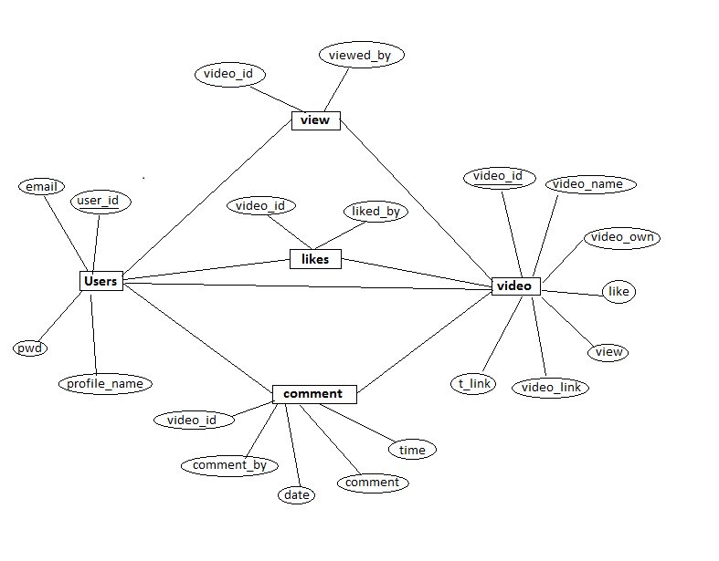

Fig: Block Diagram

1. features and usefulness
2. Annonymous Video viewing
3. Annonymous uploading
4. For Like have to be user but user information will be classified
5. For Comment have to be user but user information will be classified
6. Popular videos
7. Topics wise video upload
8. Will be an open platform for all who want to express their will anonymously
9. Limitations

Nothing is perfect. It is just how close we get. As for this project there are tons of limitations. Let’s see some of them:

1. Interface is one of them. Interface can be more attractive
2. There is no ajax used in search box
3. There is no playlist feature
4. While playing a video no suggestion appeared with it
5. Problem with comment new line not using
6. No dynamic checking for checking for new use ‘already exist’
7. No share option
8. Video player can be more customized
9. future plan

With all of those limitations we have to go forward next time. So, we have some future plans:

1. We will add playlist feature
2. Video suggestion
3. Share option
4. Customized video player
5. conclution

Butterfly is project (website) that is made for mainly uploading video with everyone and view others without exposed own identity. We know this was a very small part of main project. But this can be used in various option. So, we can speak our words by video as like a butterfly in the sky.

11. Reference

* [W3Schools Online Web Tutorials](http://www.w3schools.com/)
* [TutorialsPoint](https://www.tutorialspoint.com/)
* [PHP: A simple tutorial - Manual](php.net/manual/en/tutorial.php)
* [SQLCourse - Interactive Online SQL Training for Beginners](http://www.sqlcourse.com/)
* [HTML5 Tutorial](https://thenewboston.com/videos.php?cat=43)

acknowledgement

A word of special thanks must go to our highly esteemed teacher and this project’s supervisor, Mr. Jakaria Rabbi, Department of computer Science & Engineering, KUET-9203, for his excellent advices and right directions without which our project may not have reached a state it is in now.

SB:

Any constructive comments, suggestions, criticism from teachers as well as seniors will be highly appreciated and gratefully acknowledged